Job Description 
JOB TITLE: Marketing and Communications Officer
LOCATION: Petty Pool Vocational College, Pool Lane, Sandiway, Cheshire, CW8 2DR
REPORTS TO: Head of Marketing and Fundraising
SALARY: £25,677.60 – £26,447.93
HOURS: 35 hours per week -Monday to Friday, 8:30am - 4:30pm, Hybrid working
DBS: Enhanced check required.
Marketing and Communications Officer
We have a fantastic opportunity for a Marketing and Communications Officer to join the Marketing, Communications and Fundraising function at Petty Pool. You will support our internal and external communications strategy, design, write and circulate publicity and marketing material, responding to the needs of our wider team and the strategic mission of the organisation.

About you

We are looking for someone who can think creatively, has a good eye for design, excellent communication skills and who can work accurately and at a pace in what is a busy department. A bachelor’s degree in a related field with experience in a communications role is strongly desired. Skills in online media and SEO as well as the use of design and digital communication tools to create and monitor effective content are essential as is the ability to work effectively in a diverse team and be able to prioritise workloads and tasks.

Roles and Responsibilities

- Implement engaging multi-channel marketing and communication campaigns to raise the profile and reach of Petty Pool.
- Write, design and issue monthly newsletters using MailChimp.
- Work with the team to maintain the Petty Pool website.
- Support the delivery of a strategic social media presence and undertake day-to-day management of Petty Pool social media channels.
- Develop a strong knowledge of Petty Pool’s activities, its learners, members, and stakeholders.
- Write accurate, engaging, and targeted copy for different audiences across a range of channels.
- Create social media graphics, banners and content using Canva.
- Support the design and production of marketing, communication and event materials ensuring consistent house style, branding, and layout.
- Be a proactive and hands-on member of a small communications team.
- To be responsible for a portfolio of running events and fundraising activities.
- To assist with the development and production of a range of fundraising materials including posters, our online fundraising newsletter, and thank you to donors.
- To work closely with key internal stakeholders both to understand and be able to package up their work into clear compelling asks to prepare for grant and bid submissions.
- To assist, when required, with the content and production fundraising appeals and activities and any others throughout the year.
- Take responsibility for ensuring that full records of all contacts are maintained on the fundraising database.
- Be able to run and evaluate fundraising initiatives including digital campaigns.

Person Specification
Qualifications and Experience |  | Essential |  | Desirable
- Educated to degree level or equivalent. |  | P
- Strong level of IT literacy. |  | P
- Awareness of communications principles and how to apply them to meet objectives. |  | P
- Ability to communicate in an accessible and clear manner through a variety of  formats. |  | P
- Excellent written communication skills and attention to detail. |  | P
- Familiarity with and use of social media and digital content making tools. |  | P
- Excellent interpersonal skills, with the ability to build relationships across the organisation and with other stakeholders. |  | P
- Excellent organisational skills, with ability to cope with a full and varied workload, prioritise and work to deadlines. |  | P
- Positive and collaborative attitude and willingness to go the extra mile to help themselves and others achieve goals. |  | P
- Experience of running and evaluating fundraising initiatives including digital campaigns |  | P
Knowledge and Skills |  | Essential |  | Desirable
- Excellent interpersonal skills, with the ability to build relationships across the organisation and with other stakeholders. |  | P
- Excellent organisational skills, with ability to cope with a full and varied workload, prioritise and work to deadlines. |  | P
- Positive and collaborative attitude and willingness to go the extra mile to help themselves and others achieve goals. |  | P
 | Personal Competencies |  | Essential |  | Desirable
 | - Ability to work calmly under pressure, prioritise & manage own workload
 | - Flexibility, enthusiasm and a positive attitude at all times
 | - Honesty, fairness and reliability in all matters

Our college is committed to safeguarding and promoting the welfare of our children and young people and expects all staff and volunteers to share this commitment.

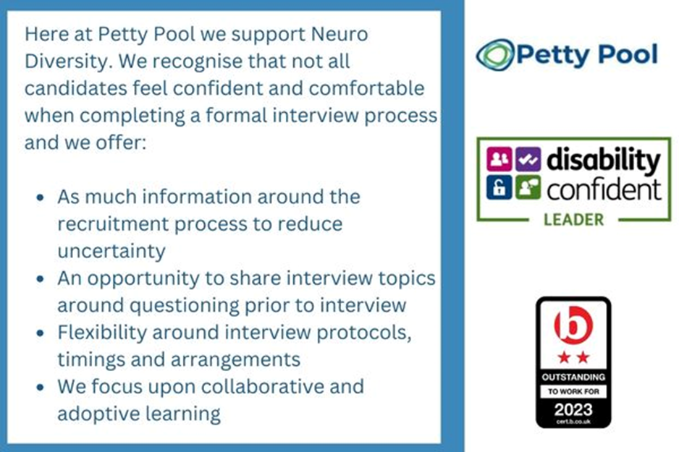
Petty Pool is an equal-opportunity employer. We are committed to equality of opportunity for all staff and applications from individuals are encouraged regardless of age, disability, sex, gender reassignment, sexual orientation, pregnancy and maternity, race, religion or belief and marriage and civil partnerships.

