

Job Description
JOB TITLE: Tutor
LOCATION: Petty Pool Vocational College, Pool Lane, Sandiway, Cheshire, CW8 2DR
REPORTS TO: Curriculum Managers
SALARY: £28,644.89 - £34,818.04
HOURS: Monday – Friday 8.30am – 4.30pm (Term Time 41 weeks)
DBS: Enhanced check required

Tutor
Summary
Responsible for the efficient and effective running of your department, you will plan, deliver and assess learners with High Needs on 16-19 Study Programmes. This will include the design & production of appropriate learning and assessment materials and the practical delivery of sessions for accredited qualifications ranging from pre-entry to Level 1, depending on course/cohort. The role will also include the pastoral care of learners on your course.

Responsibilities
- Initial, diagnostic, baseline and ongoing assessments in vocational area and also functional skills using BKSB
- To set appropriate SMART targets via the Individual Learning Plans (ILP)
- To carry out regular reviews; record, track, monitor and report on learner progress and complete evaluations
- To produce detailed Schemes for Learning for the curriculum pathway
- To prepare appropriate learning and assessment materials
- To deliver high quality lessons
- To identify opportunities for learners to demonstrate competence and collect evidence.
- To identify valid and sufficient evidence and sources of evidence to meet national standards.
- To deliver training & education to prescribed standards, meeting the requirements of funding bodies.
- To teach in a variety of styles
- To individualise personalise learning for all
- To manage Learner Mentors effectively to maximise learning, providing them with clear instructions.
- To plan Internal Work Experience and provide Learner Mentors with guidance to support learners
- To accurately assess and record students additional support requirements, building on EHC plans
- To report and log student incidents allowing a comprehensive case of additional support to be compiled
- To comply with Safeguarding and Prevent policy and procedures at all times, ensuring the safety of all learners
- To provide a positive role model for all students and act as a Personal Tutor providing pastoral care and support
- To deliver group tutorial sessions, 1:1 tutorial discussions and monitor target setting and progress
- To develop learner’s skills for work and life to meet individual personal, social & wellbeing needs
- To plan & deliver an Enrichment programme of activities to enhance the learner experience of college life
- To motivate, advise and support students at all times
- To work as part of a team sharing ideas and experiences
- To promote and maintain a stimulating, progressive classroom environment
- To demonstrate consistent confidentiality in all matters concerning students
- To take responsibility for students when taking part in off-site activities
- To take responsibility for students whilst transporting them in Petty Pool Trust vehicles
- To take responsibility for maintaining Health & Safety on and off site, undertaking relevant risk assessment activity
- To organise and facilitate suitable vocational work placements for learners on the course to be accessed on a rota basis
- To utilise existing links to enhance the course and develop new community projects through partnership opportunities
- To be proactive in cultivating new links with industry and organisations active in the vocational area
- To participate in college observation systems in order to quality assure Teaching, Learning and Assessment
- To take part in training and CPD opportunities and required by the college
- To take part in residential holidays as required by the college
- To support the ethos of the college and promote equality and diversity
- To be flexible and easily able to adapt to changes in duties, routine and circumstances
- To accept the daily fluctuations within the organisation and support requirements of learners

NOTE: In accordance with the Trust’s flexibility policy, the post holder will be required to undertake any other duties considered commensurate with this position, as directed by The Senior Management Team of The Petty Pool Trust, or as a mutually agreed developmental opportunity.

Person Specification
Qualifications and Experience | Essential | Desirable
English and Maths GCSE or equivalent at grade C or above
Hold a higher-level qualification in specific Vocational Area
Hold or be working towards a PGCE / Cert.Ed. qualification
OR Hold or be working towards PTLLS / CTLLS / DTLLS qualification
Educated to Degree level or above
Experience of people with learning disabilities
Experience of working within Further Education
Experience of teaching Functional Skills
Hold or be working towards ECDL or equivalent IT qualification
Hold or be working towards a Basic First Aid Certificate
Hold or be working towards qualifications in Safeguarding and Prevent
Knowledge and Skills | Essential | Desirable
Previous experience of delivering accredited learning
Experience of planning programmes for learners between pre-entry & level 1
Experience of providing pastoral care through the personal tutor role
Understanding of Initial, Diagnostic and Baseline Assessments
Previous experience of BKSB Functional Skills package
Understanding of target setting and monitoring of progress
Experience of contextualising Functional skills into a range of skill areas (Vocational & ILS)
Excellent organisational skills
Excellent ICT skills
Ability to meet legal requirements & understanding of Health & safety legislation
Ability to multi task and plan ahead
Ability to work within financial budgetary controls
Ability to give effective feedback
Awareness of group dynamics
Full clean drivers licence (Manual Car)
Previous experience of working with people with learning disabilities
Experience & understanding of college systems
Knowledge of recent developments / legislation in FE
Knowledge of additional support requirements / High needs learners
Personal Competencies | Essential | Desirable
Sense of humour and caring nature; sensitivity, empathy and tolerance.
Ability to work calmly under pressure, prioritise & manage own workload
Empathy with learners and with issues facing young adults
Flexibility, enthusiasm and a positive attitude at all times
Honesty, fairness and reliability in all matters

Our college is committed to safeguarding and promoting the welfare of our children and young people and expects all staff and volunteers to share this commitment.

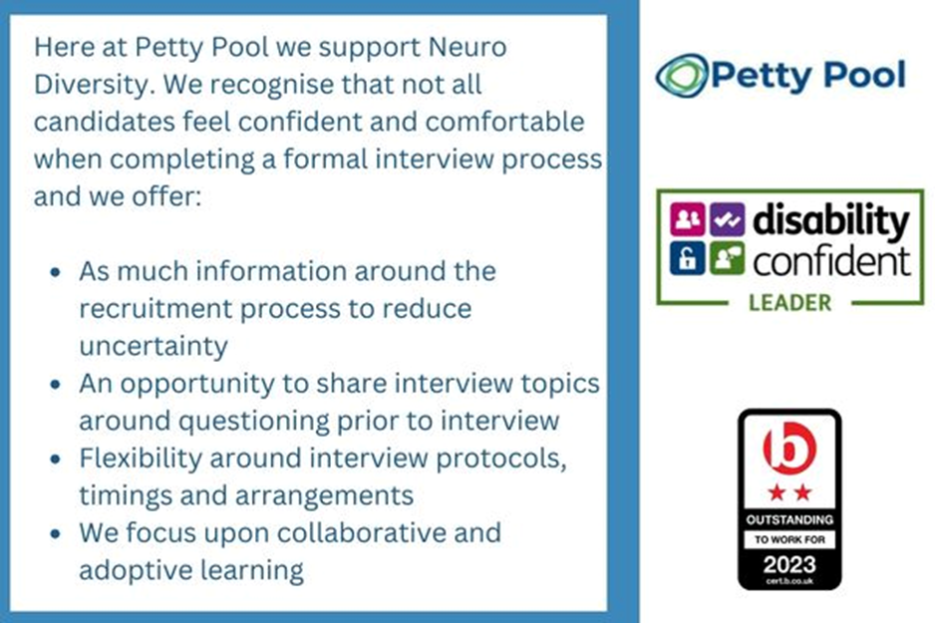
Petty Pool is an equal-opportunity employer. We are committed to equality of opportunity for all staff and applications from individuals are encouraged regardless of age, disability, sex, gender reassignment, sexual orientation, pregnancy and maternity, race, religion or belief and marriage and civil partnerships.

